**Name: Trần Nguyễn Quang Vinh**

**Student code: SE184691**

**Subject: PRF192- PFC**

**Workshop 02**

**Objectives:**

Practicing skills at analyzing and implementing simple programs

**Ex1 ( 1 marks )** : Write a C program to input three numbers from user and find maximum between three numbers using **conditional/ternary operator ?: .**

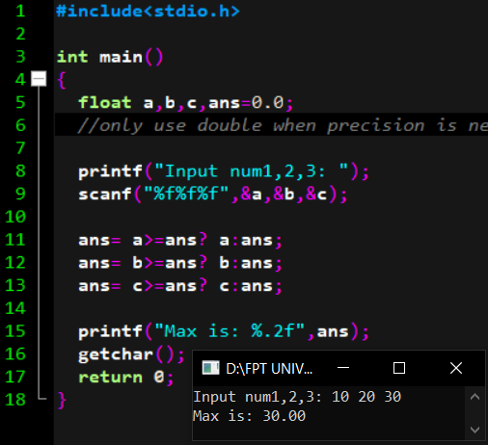

**Ex2 ( 1 marks )** : Write a C program to check positive, negative or zero using **simple if or if else**. C program to **input any number** from user and check whether the given number is positive, negative or zero

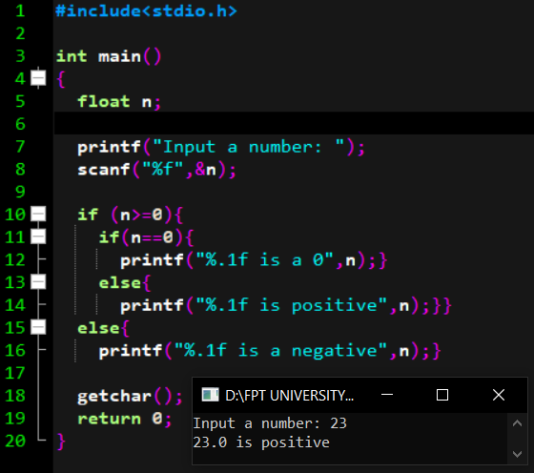

**Ex3( 2 marks )** : **– Yearly Personal Income Tax**

Suppose that:

In Viet Nam, each people has to pay for his/her yearly personal income tax as the following description:

**Rules:**

***Tax-free income:***

Personal pending amount (tiền nuôi bản thân) **pa=** 9 000 000$/month

Alimony (tiền cấp dưỡng) for each his/her dependent **pd=** 3 600 000$/month/dependent

With **n** dependents, Yearly tax-free income: **tf = 12*(pa + n*pd)**

***Taxable income (thu nhập chịu thuế)***

**ti = income – tf**

**( If ti<=0 then income tax = 0)**

**Based on taxable income, the employee has to pay his/her income tax with levels pre-defined in the following table:**

|  |  |  |
| --- | --- | --- |
| ***Level*** | ***Taxable Income*** | ***Income tax*** |
| 1 | Less than or equal to 5.000.000 | 5% |
| 2 | From 5.000.001 to 10.000.000 | 10% |
| 3 | From 10.000.001 to 18.000.000 | 15% |
| 4 | Over 18.000.000 | 20% |

Write a program which will compute income tax of a people using the following interface:

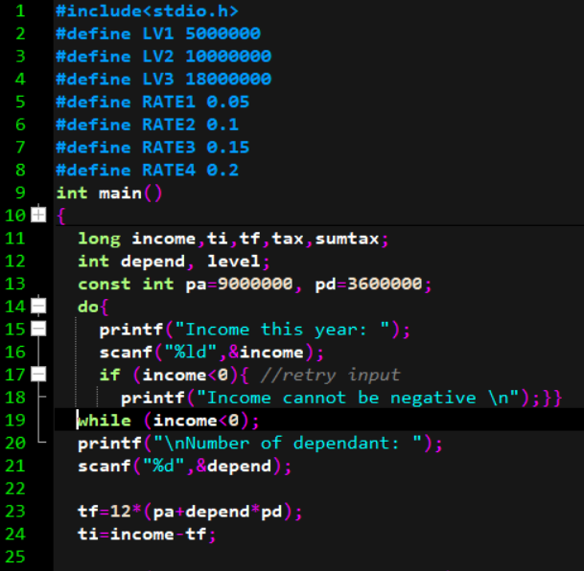

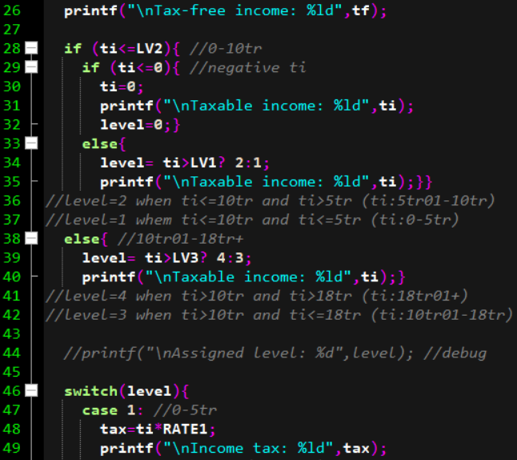

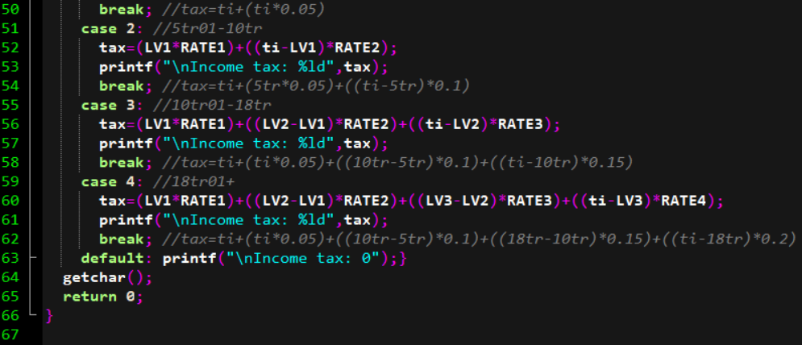

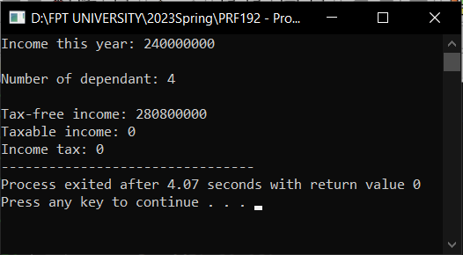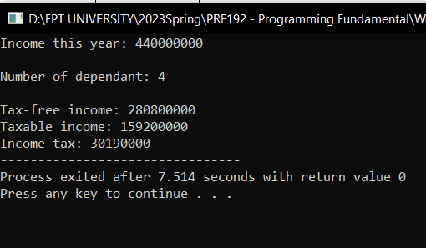

**Ex4 ( 2 marks )** : Write a C program to input month number and print total number of days in month using **switch...case.**

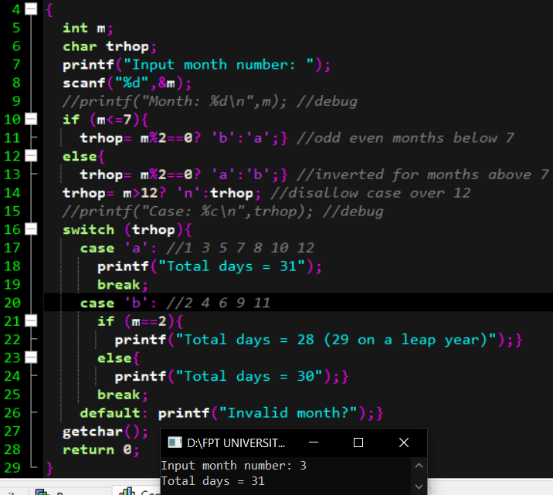

**Ex5 ( 1 marks )** : Write a C program to print all odd numbers from 1 to n using for loop

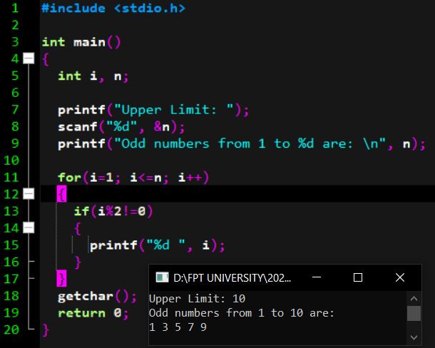

**Ex6 ( 1 marks )** : Write a C program to find the sum of all natural numbers between 1 to n using for loop.

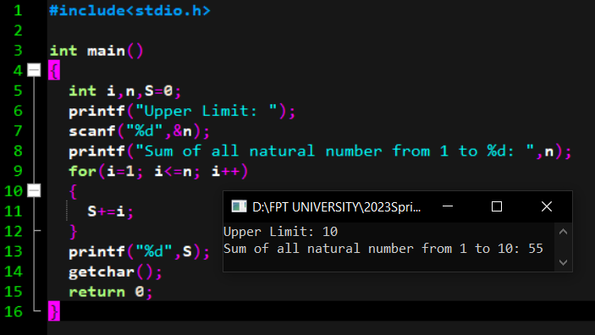

**Ex7 ( 2 marks )** : Write a C program to input a number from user and count number of digits in the given integer using loop.

